

# GRT INSTITUTE OF ENGINEERING AND TECHNOLOGY, TIRUTTANI - 631209

**Approved by AICTE, New Delhi Affiliated to Anna University, Chennai**

## DEPARTMENT OF COMPUTER SCIENCE AND ENGINEERING

#### COVID-19 VACCINE ANALYSIS USING DATA SCIENCE

**PROJECT REPORT**

**SUBMITTED BY**

SHANMUGA PRUDVI D

3RD YEAR 5TH SEM

110321104008

[dshanmugaprudvi@gmail.com](mailto:dshanmugaprudvi@gmail.com)

ANNA UNIVERSITY:CHENNAI 600 025

# BONAFIDE CERTIFICATE

Certified that this project report **“COVID VACCINE ANALYSIS USING DATA SCIENCE”** is the bonafide work of **SHANMUGA PRUDVI D [110321104008]”** who carried out the project

work under my our supervision.

## Dr.N. Kamal M.E.,Ph.D., Mr.T.A. Vinayagam M.Tech.,

**HOD Assistant**

## professor

Department of Computer Science And Department of Computer Science And

Engineering Engineering

GRT Institute of Engineering and GRT Institute of Engineering and

Technology Technology

Tiruttani Tiruttani

Certified that the candidates were examined in Viva-voce in the ExaminationHeld on **06/11/2023.**

# ACKNOWLEDGEMENT

We thank our Management for providing us all support to complete this project successfully. Our sincere thanks to honorable **Chairman**, **Shri. G. RAJENDRAN and Managing Director, Shri.G.R. RADHAKRISHNAN** for creating a wonderful atmosphere inside the campus.

We are very grateful to **Dr.S. ARUMUGAM, M.E., Ph.D., Principal**, for providing us with consistent guidance and motivation to execute a real time project to learn and experience the project work in an environments to complete our project successfully.

Our sincere thanks to **Dr.N. KAMAL, M.E., Ph.D., Professor and Head, Department of Computer Science and Engineering** for giving me this wonderful opportunity to do the project and providing the require facilities to fulfill our work.

We are highly indebted and thankful to our project Evaluators **Mrs V. Priya M.E**., and **Mrs. Edith Esther M.E., Assistant Professor, Department of Computer Science andEngineering** for his immense support in doing the project.

We are very grateful to our internal guide **Mr. T.A. VINAYAGAM, M.Tech., AssistantProfessor, Department of Computer Science and Engineering** for guiding us with her valuable suggestions to complete our project.

We also dedicate equal and grateful acknowledgement to all the **respectable members of thefaculty and lab in-charges** of the Department of Computer Science and Engineering, friends andour families for their motivation, encouragement and continuous support.

Our sincere thanks **to IBM and Skill Up Team members** for giving me this wonderful opportunity to do the projectand providing the require guidance and valuable online sessions.

## COVID-19 VACCINES ANALYSIS USING DATASCIENCE ABSTRACT

The study found that vaccines were perceived as safe by those who had or planned to obtain full vaccination and those who indicated trust in science.

On the other hand, vaccines were perceived as not safe by those who self-identified as Republicans vs. self-identified Democrats and those with high school or lower education. The study also found that the following groups were most likely to reject vaccination based on belief in vaccinations: those with lower income, those who do not know anyone who had been vaccinated, those who are unwilling to get vaccinated even if family and friends had done so, those who did not trust science, those who believe that vaccination was unnecessary if others had already been vaccinated, and those who indicate refusal to vaccinate to help others.

I also found a living systematic review with trial 2 that suggests all the included vaccines are effective in preventing COVID-19. The mRNA vaccines seem most effective in preventing COVID-19, but viral vector vaccines seem most effective in reducing mortality. Further trials and longer follow-up are necessary to provide better insight into the safety profile of these vaccines.

|  |  |  |
| --- | --- | --- |
|  | **TABLE OF CONTENTS** |  |
| **CHAPTER**  **No** | **TITLE** | **PAGE**  **No** |
|  | **ABSTRACT** |  |
| **1.** | **PHASE 1** |  |
|  | 1.0 INTRODUCTION |  |
|  | 1.1 PROBLEM DEFINITION |  |
|  | 1.2 DESIGN THINKING |  |
|  | 1.3 OBJECTIVES |  |
|  | * 1. SYSTEM DESIGN AND THINKING   2. SYSTEM ARCHITECTURE | **8-16** |
|  | 1.6 E – R DIAGRAM |  |
|  | 1.7 USE CASE DIAGRAM |  |
|  | 1.8 ARCHITECTURE |  |
|  | 1.9 SEQUENCE DIAGRAM |  |
| **2.** | **PHASE 2** |  |
|  | 2.1 SHORT EXPLAINATION ABOUT |  |
|  | CUSTOMER SEGMENTATION USING |  |
|  | DATA SCIENCE |  |

|  |  |  |
| --- | --- | --- |
|  | 2.2 WHERE I GOT THE DATASETS AND |  |
|  | ITS DETAILS |  |
|  | 2.3 DETAILS ABOUT COLUMNS | **17-24** |
|  | 2.4 DETAILS OF LIBRARIES TO BE USED |  |
|  | AND WAY TO DOWNLOAD |  |
|  | 2.5 HOW TO TRAIN AND TEST THE |  |
|  | DATASET |  |
|  | 2.6 REST OF EXPLAINATION |  |
|  | 2.7 WHAT METRICS USED FOR THE |  |
|  | ACCURACY CHECK |  |
|  | **PHASE 3** |  |
| **3.** |  |  |
|  | 3.1 DATASET AND ITS DETAIL |  |
|  | EXPLANATION AND IMPLEMENTATION OF |  |
|  | CUSTOMER SEGMENTATION USING |  |
|  | DATA SCIENCE |  |
|  | 3.2 BEGIN BUILDING THE PROJECT BY | **25-35** |
|  | LOAD THE DATASET CUSTOMERIDS |  |
|  | 3.3 PREPROCESS DATASET |  |
|  | 3.4 PERFORMING DIFFERENT ANALYSIS |  |
|  | NEEDED |  |

|  |  |  |
| --- | --- | --- |
| **4.** | **PHASE 4**   * 1. : IN THIS TECHNOLOGY YOU WILL CONTINUE BUILDING YOUR PROJECT BY PREPROCESSING YOUR DATASET   2. : IN THIS TECHNOLOGY YOU WILL CONTINUE BUILDING YOUR PROJECT BY PERFORMING FEATURE ENGINEERING 4.3:MODEL TRAINING AND EVALUATION 4.4: PERFORM DIFFERENT ANALYSIS AS NEEDED | **36-42** |

### CHAPTER 1

**PHASE 1**

### INTRODUCTION

The COVID-19 pandemic, caused by the novel coronavirus SARS-CoV-2, has presented an unprecedented global challenge, leading to widespread illness, loss of life, and significant economic and social disruption.

As the pandemic unfolded, the scientific community rallied to develop vaccines at an unprecedented pace. Multiple COVID-19 vaccines have been developed and deployed globally, marking a historic milestone in the field of medicine.

This data science project aims to analyze various aspects of COVID-19 vaccines to provide valuable insights into their effectiveness, distribution, impact on public health, and more.

Leveraging a wealth of available data, this analysis seeks to answer crucial questions related to the vaccination efforts against COVID-19.

It will not only explore the technical aspects of vaccine development but also delve into the social, economic, and health-related ramifications of these vaccines.

### PROBLEM DEFINITION

The problem at hand involves conducting a comprehensive analysis of COVID-19 vaccines from a data science perspective. This analysis seeks to address several key questions and challenges related to COVID-19 vaccinations, with the ultimate goal of contributing to the global understanding and management of the pandemic. The primary problem areas include:

* + 1. Vaccine Efficacy Assessment: Evaluate the effectiveness of various COVID-19 vaccines in preventing infections, reducing severe illness, and preventing mortality. Determine how different factors such as vaccine type, demographics, and timing impact efficacy rates.
    2. Vaccine Distribution and Accessibility: Investigate the global distribution of COVID-19 vaccines, identifying regions or populations with limited access to vaccinations. Analyze the reasons behind disparities in vaccine distribution and explore potential solutions to improve accessibility.
    3. Vaccine Safety Analysis: Examine the safety profile of COVID-19 vaccines by analyzing reported adverse events and side effects. Identify any patterns or trends in adverse reactions and assess their significance in the context of public health.
    4. Transmission and Herd Immunity: Analyze data to understand the role of COVID-19 vaccines in reducing virus transmission within communities. Determine if vaccinated individuals are less likely to transmit the virus and estimate vaccination coverage required to achieve herd immunity.
    5. Long-Term Effectiveness: Investigate the long-term effectiveness of COVID-19 vaccines, including the potential need for booster shots and the durability of immunity over time. Assess factors influencing long-term protection.

**Problem statement :**

The problem is to conduct a comprehensive analysis of COVID-19 vaccines to assess their efficacy, safety, distribution, and impact on public health. This analysis should provide insights for policymakers, healthcare professionals, and the public to make informed decisions regarding vaccination strategies and public health interventions.

**Key Objectives:**

Efficacy Assessment: Evaluate the effectiveness of different COVID-19 vaccines in preventing infection, transmission, and severe outcomes (hospitalization and death).

**Safety Evaluation:** Assess the safety profile of COVID-19 vaccines, including adverse events, side effects, and potential long-term effects.

Distribution and Access: Analyze the distribution and accessibility of vaccines to ensure equitable access for all populations, including vulnerable and underserved communities.

**Public Health Impact:** Quantify the impact of vaccination campaigns on reducing the spread of the virus, hospitalizations, and mortality rates.

**Variants Analysis:** Investigate how vaccines perform against emerging variants of the virus and recommend adjustments or booster strategies if necessary.

**Vaccine Hesitancy:** Examine factors contributing to vaccine hesitancy and develop strategies to address this issue.

**Data Sources:** Collect and curate data from various sources, including clinical trials, real-world studies, government health agencies, and global health organizations.

Modeling and Predictions: Develop models to forecast the trajectory of the pandemic based on vaccination rates and other factors.

**Ethical Considerations:** Address ethical concerns related to data privacy, informed consent, and equitable vaccine distribution.

**Approach:**

Data Collection: Gather and clean data from diverse sources, including clinical trials, healthcare databases, and vaccination records.

**Statistical Analysis:** Apply statistical methods to compare vaccine effectiveness, safety profiles, and distribution patterns.

**Machine Learning:** Develop predictive models to estimate the impact of vaccination on the spread of the virus and the likelihood of new variants emerging.

**Geospatial Analysis:** Utilize geographic information systems (GIS) to visualize vaccine distribution and identify underserved areas.

**Ethical Review:** Ensure that data collection and analysis follow ethical guidelines and respect individual privacy.

**Communication:** Disseminate findings through reports, visualizations, and public communication to inform decision-makers and the general public.

**Challenges:**

Variability in vaccine effectiveness and safety.

Rapidly evolving scientific understanding of COVID-19 and vaccines. Ethical dilemmas in data collection and sharing.

Addressing vaccine hesitancy. Ensuring equitable access to vaccines. Adapting to new variants of the virus. **Deliverables:**

Research papers and reports.

Data visualizations and dashboards.

Policy recommendations for vaccine distribution. Public awareness campaigns.

A comprehensive analysis of COVID-19 vaccines is essential for managing the ongoing pandemic effectively, ensuring public safety, and making informed decisions regarding vaccination strategies and public health policies.

### DESIGN THINKING

Design thinking can be a valuable approach to tackle the analysis of COVID-19 vaccines. It involves a user-centered, iterative process that emphasizes empathy, problem-solving, and creativity. Here's a design thinking framework for COVID-19 vaccines analysis:

#### Empathize:

Understand the needs, concerns, and expectations of various stakeholders, including policymakers, healthcare professionals, and the general public.

Conduct interviews, surveys, and gather qualitative data to empathize with the target users.

#### Define:

Clearly define the problem and the specific challenges related to COVID-19 vaccines analysis. Develop a user-centric problem statement based on the insights gained from the empathy phase.

#### Ideate:

Generate a wide range of innovative ideas and solutions for analyzing COVID-19 vaccines.

Encourage brainstorming sessions involving cross-functional teams, including data scientists, healthcare experts, and communication specialists.

#### Prototype:

Create prototypes of potential analysis approaches, tools, or visualizations.

Develop data models, analytical frameworks, and visualization concepts to represent the analysis effectively.

#### Test:

Test the prototypes with real data and stakeholders to gather feedback and refine the analysis methods. Iteratively improve the prototypes based on user feedback and data-driven insights.

#### Implement:

Transform the refined analysis prototypes into actionable strategies and tools. Develop data pipelines, models, and dashboards for COVID-19 vaccine analysis.

#### Communicate:

Effectively communicate the findings and recommendations to various stakeholders using clear, accessible, and compelling visuals and narratives.

Consider the needs of non-technical audiences in your communication.

#### Learn and Iterate:

Continuously gather feedback and assess the impact of the vaccine analysis on public health decisions.

Adapt to emerging challenges and data sources, including the evolution of the pandemic and the introduction of new vaccines or variants.

#### Design Thinking Principles for COVID-19 Vaccines Analysis:

Human-Centered: Prioritize the needs and concerns of users, including healthcare workers, policymakers, and the general public, in the design of vaccine analysis tools and communication.

Iterative Approach: Embrace an iterative process that allows for constant improvement and adaptation as new data and challenges arise during the pandemic.

Collaborative Teams: Bring together multidisciplinary teams, including data scientists, public health experts, and communication professionals, to ensure a holistic approach to vaccine analysis.

Visualization and Storytelling: Use compelling data visualizations and narratives to make the analysis results accessible and actionable for a wide audience.

Ethical Considerations: Always be mindful of ethical concerns related to data privacy, informed consent, and equitable access to vaccines in your analysis and communication.

Flexibility: Stay flexible and responsive to the evolving nature of the pandemic, including the emergence of new variants and vaccination strategies.

Design thinking provides a structured, user-centric approach to COVID-19 vaccine analysis, ensuring that the analysis methods and communication strategies are well-aligned with the needs of the stakeholders and the dynamic nature of the pandemic.

### OBJECTIVES

The objectives of COVID-19 vaccines analysis are multi-faceted and essential for understanding the impact, effectiveness, and safety of COVID-19 vaccines. Here are the primary objectives of such analysis:

#### Efficacy Assessment:

Evaluate the effectiveness of COVID-19 vaccines in preventing COVID-19 infection, transmission, and severe outcomes such as hospitalization and death.

Analyze the durability of vaccine protection over time and the impact of vaccination on the spread of the virus within the population.

#### Safety Evaluation:

Monitor and assess the safety profile of COVID-19 vaccines, including the identification and evaluation of adverse events, side effects, and their severity.

Investigate the occurrence of rare or long-term adverse effects associated with vaccination.

#### Distribution and Access:

Analyze the distribution and accessibility of COVID-19 vaccines to ensure equitable access for all populations, including underserved communities and marginalized groups.

Identify barriers to vaccine distribution and recommend strategies for overcoming these challenges.

#### Public Health Impact:

Quantify the impact of COVID-19 vaccination campaigns on reducing the spread of the virus, hospitalizations, and mortality rates.

Assess the cost-effectiveness of vaccination strategies and their contribution to public health outcomes.

#### Variants Analysis:

Investigate how COVID-19 vaccines perform against emerging variants of the SARS-CoV-2 virus.

Recommend adjustments to vaccination strategies, including the need for booster doses or modified vaccines to address new variants.

#### Vaccine Hesitancy and Equity:

Analyze factors contributing to vaccine hesitancy and propose strategies to address this issue, including effective communication, community engagement, and education.

Ensure that vaccination efforts are equitable and prioritize vulnerable and at-risk populations.

#### Data Integrity and Transparency:

Ensure the integrity of data used in vaccine analysis and promote transparency in reporting and sharing vaccine-related information.

Address issues related to data quality and completeness.

#### Public Communication:

Effectively communicate the findings and recommendations of vaccine analysis to policymakers, healthcare professionals, and the general public.

Disseminate information in an accessible and understandable manner, addressing concerns and misinformation.

#### Adaptive Strategy Development:

Adapt vaccine distribution and administration strategies in response to evolving scientific evidence, new variants, and changing vaccination rates.

Continuously assess and update vaccination strategies as the situation evolves.

#### Ethical Considerations:

Ensure that vaccine analysis respects ethical guidelines, including privacy, informed consent, and data security.

Promote transparency and ethical data collection and sharing.

#### Global Collaboration:

Collaborate with international health organizations and other countries to share data, best practices, and coordinate efforts in the fight against COVID-19.

These objectives collectively aim to provide a comprehensive understanding of COVID-19 vaccines, their impact on public health, and the strategies needed to mitigate the pandemic effectively. Achieving these objectives is essential for informed decision-making and the successful management of the COVID-19 crisis.

### SYSTEM DESIGN AND THINKING

**2.1SYSTEM ARCHITECTURE**

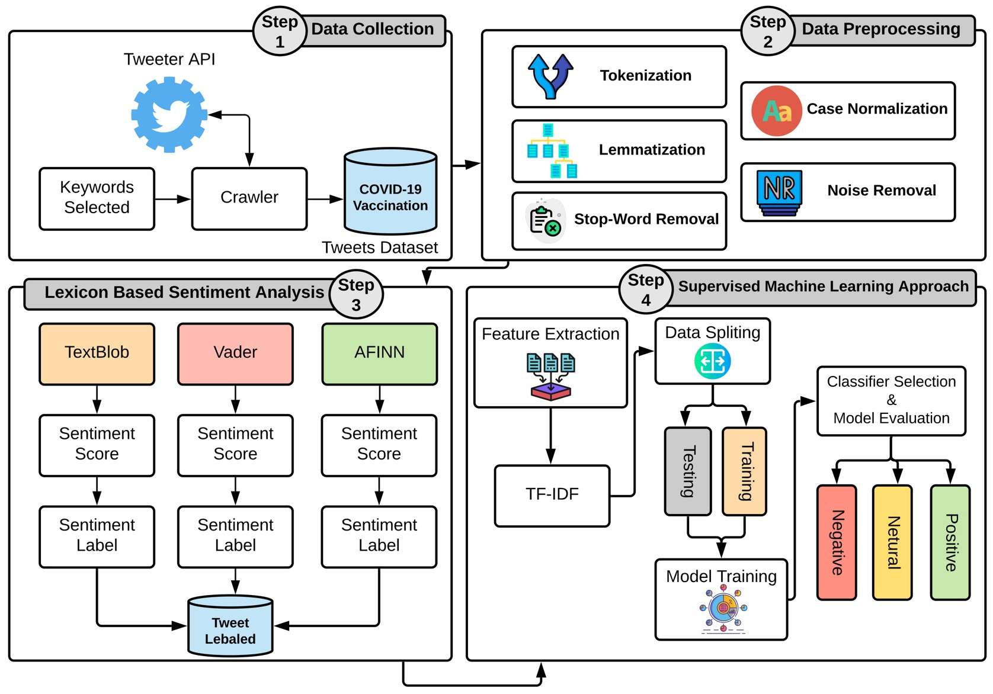

### E – R DIAGRAM

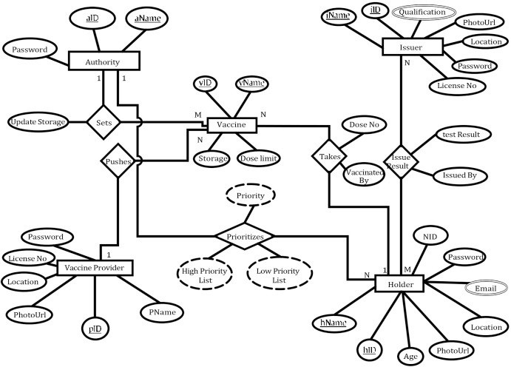

* 1. **USE CASE DIAGRAM**

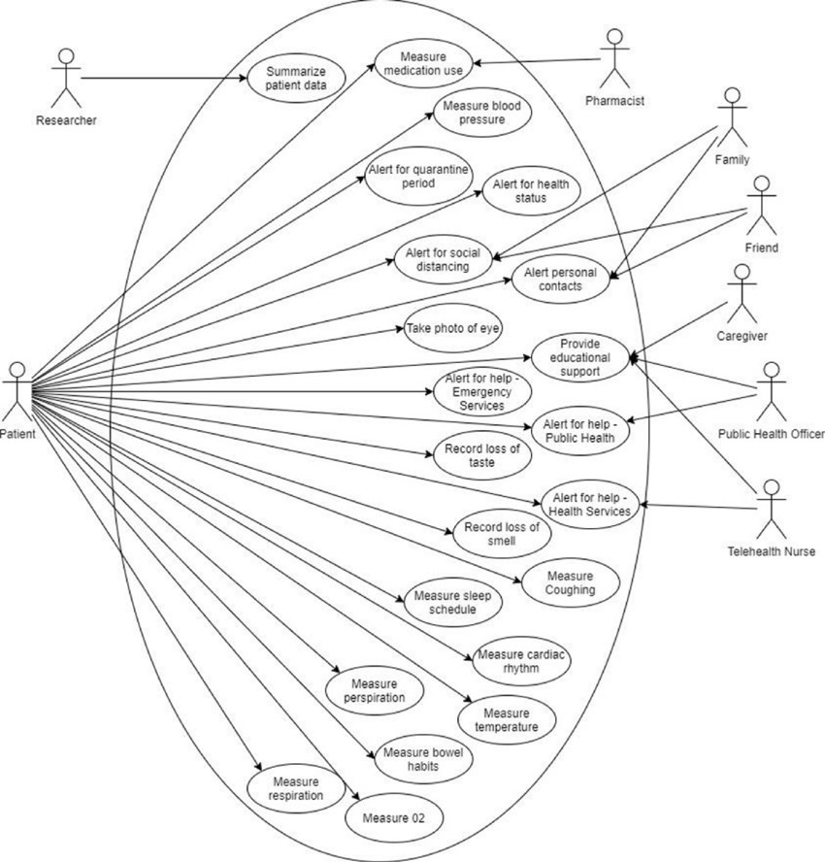

### 2.1 ARCHITECTURE

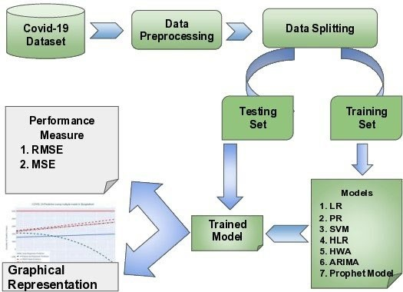

* 1. **SEQUENCE DIAGRAM**

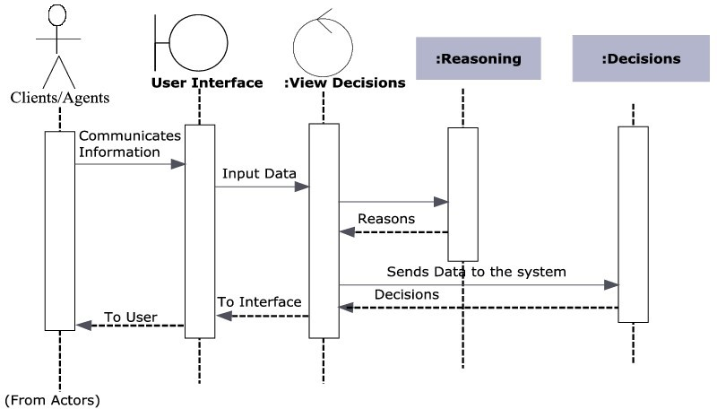

### CHAPTER 2

**PHASE 2**

* 1. **SHORT EXPLAINATION ABOUT COVID-19 VACCINES ANALYSIS USING DATA SCIENCE**

COVID-19 vaccines analysis is a systematic process of evaluating and understanding the effectiveness, safety, and impact of COVID-19 vaccines. This analysis encompasses assessing how well vaccines prevent COVID-19 infections and severe outcomes, monitoring their safety, analyzing vaccine distribution and equity, and quantifying their impact on public health.

It also involves tracking vaccine performance against new variants and addressing vaccine hesitancy. The goal is to provide data-driven insights that inform vaccination strategies, policy decisions, and public health efforts in the ongoing fight against the COVID-19 pandemic.

### WHERE I GOT THE DATASETS AND ITS DETAILS

You can find datasets for customer segmentation and various other data science projects from several reputable sources.

**KAGGLE :** Kaggle is a popular platform for data science competitions and dataset sharing. Ithosts a wide range of datasets on various topics, including customer data. You can browse datasets, read their descriptions, and download them for free. Kaggle also provides a community where you can discuss and collaborate on data science projects.

**Website :** [**https://www.**](http://www.kaggle.com/datasets/gpreda/covid-world-vaccination-progress)**kaggle.**[**com/datasets/gpreda/covid-world-vaccination-progress**](http://www.kaggle.com/datasets/gpreda/covid-world-vaccination-progress)

**NAME OF THE DATASET :** COVID-19 World Vaccination Progress

DATA DESCRIPTION :

**Clinical Trial Data:**

Information from the controlled clinical trials conducted by vaccine manufacturers, including vaccine efficacy, safety profiles, and data on adverse events.

Data on the study population, including demographics, pre-existing medical conditions, and the vaccine dosage regimen.

**Real-World Data:**

Data collected from the general population after vaccines are distributed, providing insights into real- world vaccine effectiveness and safety.

This data includes outcomes of vaccinated individuals, including COVID-19 infection rates, hospitalizations, and deaths, as well as adverse event reports.

**Vaccine Distribution Data:**

Information about the distribution and administration of COVID-19 vaccines, including the number of doses distributed, administered, and remaining.

Data on the geographic distribution of vaccines to assess equitable access.

**Variant Data:**

Genomic data on SARS-CoV-2 variants to evaluate vaccine performance against different strains. Sequencing data to track the prevalence and spread of variants.

**Vaccine Hesitancy Surveys:**

Survey data to understand public attitudes, beliefs, and concerns about COVID-19 vaccines. Data on reasons for vaccine hesitancy and strategies to address it.

**Demographic and Health Data:**

Demographic information about the population, including age, gender, ethnicity, and location. Health-related data, such as pre-existing medical conditions, comorbidities, and vaccination history. **Epidemiological Data:**

Data related to the spread of COVID-19, including infection rates, hospitalizations, and mortality rates.

Trends in the pandemic, including waves, surges, and geographic hotspots.

**Ethical and Privacy Data:**

Data related to ethical considerations, informed consent, data privacy, and ethical data sharing practices.

Information about the protection of sensitive health data.

**Communication and Media Data:**

Data related to public communication efforts, including public health campaigns, media coverage, and social media sentiment analysis.

Information on misinformation and disinformation related to COVID-19 vaccines.

**Vaccination Strategies Data:**

Data on vaccination strategies implemented by different regions or countries, including prioritization of specific groups, vaccine distribution methods, and outreach efforts.

**Vaccine Adverse Event Reporting System (VAERS):**

Data from systems like VAERS, where healthcare professionals and the public report adverse events following vaccination.

### DETAILS ABOUT COLUMNS

The specific columns or variables in COVID-19 vaccines analysis datasets can vary depending on the data source and the objectives of the analysis. However, here are some common types of columns you might find in such datasets.

#### Patient Information:

Patient ID: A unique identifier for each individual. Age: The age of the patient.

Gender: The gender of the patient.

Ethnicity: The ethnic background of the patient.

#### Vaccination Data:

Vaccine Type: The name or code of the COVID-19 vaccine administered (e.g., Pfizer, Moderna, AstraZeneca, Johnson & Johnson).

Date of Vaccination: The date when each dose of the vaccine was administered. Dose Number: Indicates whether it's the first, second, or booster dose.

Vaccine Lot Number: The unique identifier for the vaccine batch.

Vaccination Site: The location (e.g., vaccination center, pharmacy) where the vaccine was administered.

#### Clinical and Health Data:

Pre-existing Conditions: Information on any underlying medical conditions the patient has. Allergies: Data on known allergies or allergic reactions.

Medications: Information on any medications the patient is currently taking. Medical History: Previous medical history or health conditions.

COVID-19 Test Results: Data on COVID-19 testing results, indicating whether the patient has tested positive or negative for the virus.

#### Outcome Data:

COVID-19 Diagnosis: Whether the patient was diagnosed with COVID-19 after vaccination. Severity of COVID-19: The severity of COVID-19 cases, ranging from mild to severe or fatal. Hospitalization: Whether the patient was hospitalized due to COVID-19.

Mortality: Whether the patient died due to COVID-19.

#### Adverse Events:

Adverse Events: Information on any adverse events or side effects reported after vaccination. Adverse Event Severity: The severity of adverse events, ranging from mild to severe.

#### Geographic Information:

Location: The geographic location of the patient, including country, region, and city. Vaccination Site Location: The geographic location of the vaccination site.

#### Variant Information:

SARS-CoV-2 Variant: The specific COVID-19 variant detected in the patient if applicable. Vaccine Hesitancy and Public Perception:

Reasons for Hesitancy: Data on the reasons for vaccine hesitancy or refusal.

Public Sentiment: Information about public sentiment and opinions related to vaccines, collected from surveys or social media sentiment analysis.

#### Epidemiological Data:

Infection Rates: Data on COVID-19 infection rates in the patient's region. Hospitalization Rates: Rates of hospitalization due to COVID-19 in the patient's region. Mortality Rates: Rates of COVID-19-related deaths in the patient's region.

#### Data Source Information:

Data Source ID: An identifier for the data source or organization providing the data. Data Collection Date: The date when the data was collected or reported.

### DETAILS OF LIBRARIES TO BE USED AND WAY TO DOWNLOAD

LIBRARIES TO BE USED

* + - Import numpy as np
    - Import pandas as np
    - Import matplotlib as plt
    - Import seaborn as sns
    - From sklearn cluster import Kmeans

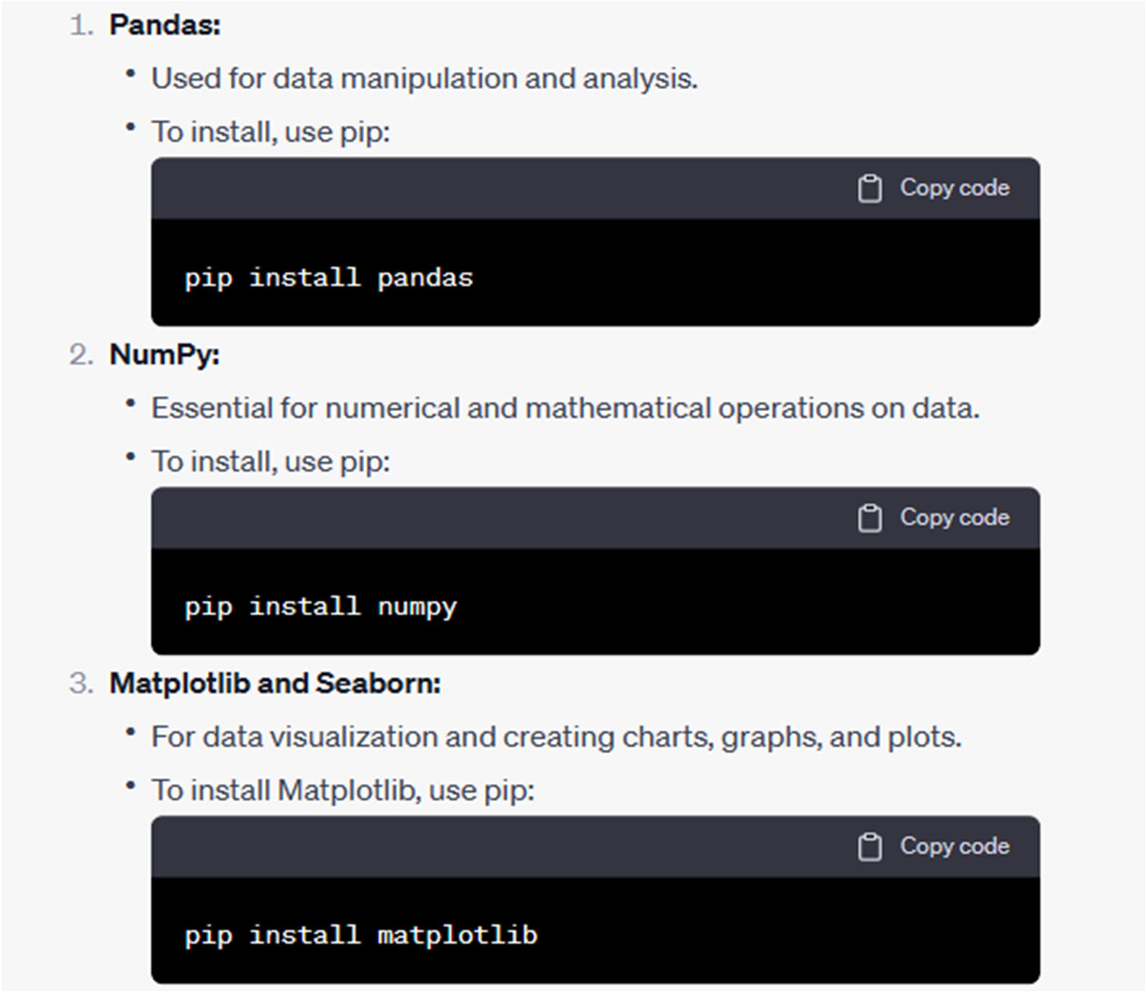WAY TO DOWNLOAD THE LIBRARIES

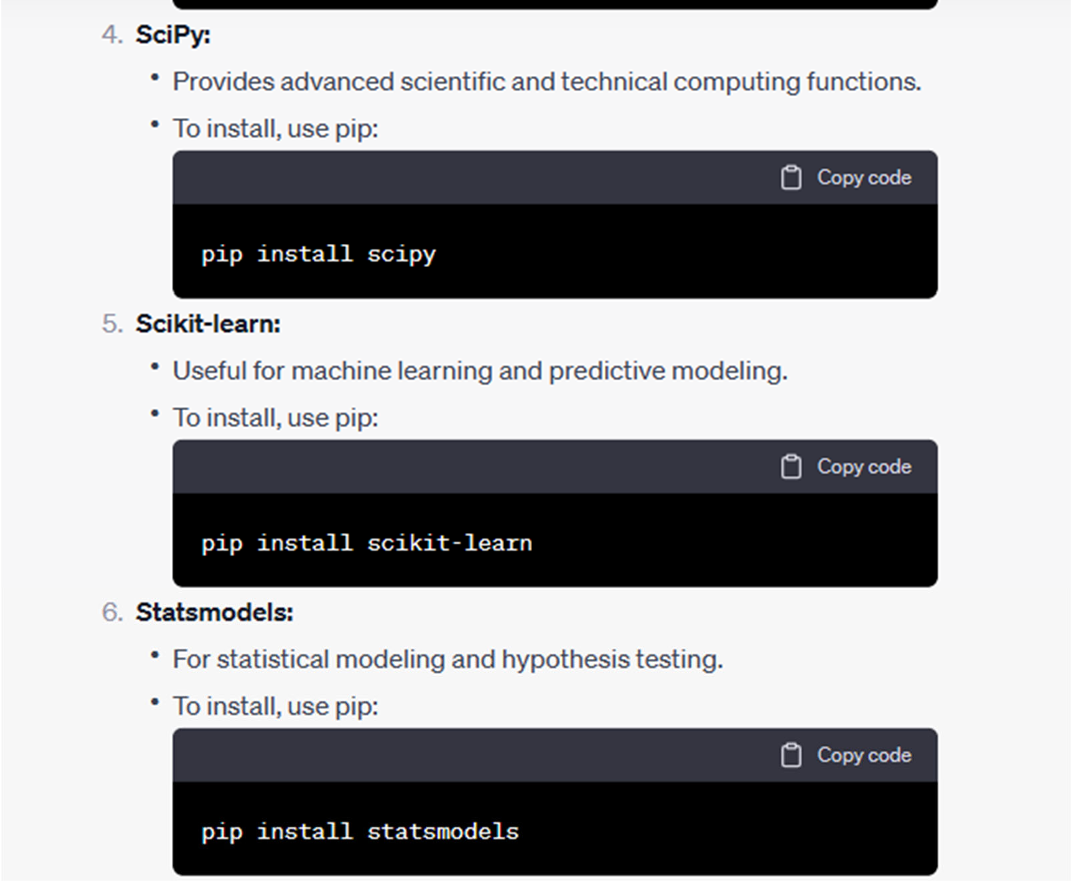

### 2.1 HOW TO TRAIN AND TEST THE DATASET

Training and testing machine learning models for COVID-19 vaccines analysis involves using your dataset to build predictive models, assess their performance, and make data-driven insights. Here's a general step-by-step process for training and testing machine learning models:

**Step 1: Data Preprocessing and Cleaning :**

Before training a model, it's crucial to prepare your dataset. This includes:

* Handling missing data.
* Encoding categorical variables.
* Scaling or normalizing numerical features.
* Splitting your dataset into training and testing sets.

**Step 2: Choose the Right Model :**

Select an appropriate machine learning model for your analysis. The choice of model will depend on the nature of the problem you're trying to solve (e.g., classification, regression) and the specific goals of your analysis.

Common models used in COVID-19 vaccines analysis include logistic regression for classification tasks (e.g., vaccine efficacy) and linear regression for regression tasks (e.g., modeling vaccine distribution).

**Step 3: Model Training :**

* Use the training dataset to train the machine learning model. This involves feeding your features (independent variables) and labels (dependent variable) to the model.
* The model learns from the training data and adjusts its internal parameters to make predictions.

**Step 4: Model Evaluation :**

After training, you need to assess the model's performance. Common evaluation metrics for classification tasks include

accuracy, precision, recall, F1-score, and area under the ROC curve (AUC). For regression tasks, you can use metrics like mean squared error (MSE) or mean absolute error (MAE).

* Apply the model to your testing dataset to make predictions.
* Compare the model's predictions with the true values (ground truth) in the testing dataset.
* Calculate the evaluation metrics to determine how well the model performs. This step helps you understand whether the model can make accurate predictions or if it needs adjustments.

**Step 5: Model Tuning and Optimization :**

Depending on the results from the model evaluation, you may need to fine-tune your model. This can involve adjusting hyperparameters, feature selection, or using different algorithms.

**Step 6: Cross-Validation (Optional) :**

In some cases, you might perform cross-validation to assess the model's robustness. Cross-validation involves splitting your dataset into multiple subsets (folds) and training and testing the model multiple times, rotating the folds.

**Step 7: Interpret the Model :**

Interpret the model to gain insights from the analysis. Depending on the type of analysis, you can examine the model's feature importance, coefficients, or other relevant information.

**Step 8: Deploy and Monitor :**

Once satisfied with your model's performance, you can deploy it for predictions or integrate it into your analysis pipeline. It's important to continuously monitor and update your model as new data becomes available or circumstances change (e.g., new vaccine variants).

Testing the Model :

Use the trained model to predict the clusters for the samples in your testing dataset.

plt.scatter(x[y_kmeans==0,0],x[y_kmeans==0,1],s=100,c="red",label = "cluster 1") plt.scatter(x[y_kmeans==1,0],x[y_kmeans==1,1],s=100,c="blue",label = "cluster 2") plt.scatter(x[y_kmeans==2,0],x[y_kmeans==2,1],s=100,c="green",label = "cluster 3") plt.scatter(x[y_kmeans==3,0],x[y_kmeans==3,1],s=100,c="cyan",label = "cluster 4") plt.scatter(x[y_kmeans==4,0],x[y_kmeans==4,1],s=100,c="magenta",label = "cluster 5") plt.scatter(kmeans.cluster_centers_[:,0],kmeans.cluster_centers_[:,1],s=300,c="yellow",label="centroids") plt.title("clusters of customers")

plt.xlabel("Yıllık gelir") plt.ylabel=("harcama skoru")

plt.legend()

Analysing the Results :

Examine the clustering results to understand how customers are grouped based on their features.

Visualize the clusters, if possible, to gain insights.

Utilizing Segmentation :

Once you have clustered customers, you can tailor marketing strategies, promotions, and storelayouts for each segment based on their characteristics.

### 2.1 REST OF EXPLAINATION

Certainly! Continuing from where we left off, here is the rest of the explanation on how to work with a mall customer dataset for customer segmentation using data science:

**Validation and Fine-Tuning :** you may want to fine-tune your model by adjusting hyperparameters or exploring different clustering algorithms. Cross-validation can help you assess the robustness of your model and choose the best configuration.

**Interpreting the Segmentation :** Interpret the meaning of each customer segment. What are the distinguishing characteristics of each group? For example, do you have a high-income, high- spending segment and a low-income, low-spending segment? Use visualizations like scatter plots or bar charts to illustrate the differences between segments.

**Targeted Marketing and Strategy :** Develop tailored marketing strategies for each customer segment. For example, create promotions or advertisements that resonate with the unique preferences and behaviours of each group. Optimize store layouts, product placements, and inventory based on the identified segments.

**Monitoring and Feedback :** Continuously monitor the effectiveness of your strategies and promotions for each segment. Collect feedback from customers in each segment and use it to make data-driven improvements.

**Retraining the Model :** Over time, as new data becomes available, consider retraining your customer segmentation model. Customer preferences and behaviours can change, and your model should adapt accordingly.

**Integration with Customer Relationship Management (CRM) :** Integrate the segmentation results with your CRM system to ensure that customer interactions and communications are personalized and consistent with the identified segments.

**Privacy and Compliance :** Ensure that you handle customer data with care and in compliancewith relevant privacy regulations (e.g., GDPR, CCPA). Anonymize or pseudonymize customerdata as needed to protect privacy.

**A/B Testing :** Implement A/B testing for marketing campaigns to measure the impact of changes on different customer segments accurately.

**Documentation and Reporting :** Document your data pre-processing steps, model selection,and results thoroughly. This documentation is essential for future reference and model maintenance.

**Scaling and Scalability :** Consider how your customer segmentation process can scale as thedataset and business grow. Ensure that your infrastructure and tools can handle larger volumesof data.

### 2.1 WHAT METRICS USED FOR THE ACCURACY CHECK

When performing customer segmentation using data science, traditional accuracy metrics like classification accuracy are not applicable because customer segmentation is an unsupervised learning task. In unsupervised learning, there are no ground truth labels to compare predictions against. Instead, you use different metrics to evaluate the quality of the segmentation. Here are some commonly used metrics for assessing the accuracy of customer segmentation:

**Silhouette Score :** The silhouette score measures how similar each data point in one cluster isto the data points in the same cluster compared to the nearest neighboring cluster. A higher silhouette score indicates better-defined clusters.

**Davies-Bouldin Index :** This index measures the average similarity between each cluster andits most similar cluster. Lower values indicate better clustering, with a lower Davies-Bouldin Index representing more distinct clusters.

**CHAPTER 3**

**PHASE 3**

* 1. **DATASET AND ITS DETAIL EXPLANATION AND IMPLEMENTATION OF COVID-19 VACCNIES ALAYSIS USING DATA SCIENCE**

## Data Collection:

Acquire a comprehensive dataset that contains information relevant to COVID-19 vaccines analysis. This dataset can come from various sources, including government health agencies, research institutions, and open data repositories. It should include details on vaccine administration, efficacy, safety, patient demographics, disease outcomes, and more.

### Data Cleaning and Preprocessing:

Prepare the dataset by cleaning and preprocessing it. This involves handling missing data, standardizing formats, encoding categorical variables, and ensuring data quality.

### Exploratory Data Analysis (EDA):

Conduct EDA to gain insights into the dataset. Visualize data distributions, relationships, and patterns. Explore factors such as vaccine coverage, demographic disparities, and disease trends.

### Define Analysis Objectives:

Clearly define the objectives of your COVID-19 vaccines analysis. Decide what specific questions you want to answer, such as evaluating vaccine effectiveness, safety, distribution equity, or addressing vaccine hesitancy.

### Feature Engineering:

Create or transform features to better represent the relationships between variables. For example, you can calculate vaccine coverage rates, create age groups, or derive new variables for analysis.

### Machine Learning Model Building:

Select appropriate machine learning models based on the nature of the analysis objectives. For classification tasks (e.g., vaccine efficacy), you can use models like logistic regression or decision trees. For regression tasks (e.g., modeling vaccine distribution), linear regression may be suitable.

### Split Data into Training and Testing Sets:

Split the dataset into training and testing subsets to train and evaluate the machine learning models. Typically, 70-80% of the data is used for training, and the remaining 20-30% is reserved for testing.

### Model Training:

Train the selected machine learning models using the training dataset. The models learn patterns and relationships within the data.

### Model Evaluation:

Assess the model's performance on the testing dataset using appropriate evaluation metrics. For classification models, you can use metrics like accuracy, precision, recall, and F1-score. For regression models, use metrics like MSE or MAE.

### Interpret Results:

Interpret the model results to understand the impact of variables on the analysis objectives. Identify significant predictors, patterns, and relationships.

This approach allows you to use data science techniques to analyze COVID-19 vaccines comprehensively and make data-driven decisions that can have a positive impact on public health. The specific dataset and implementation details will depend on the specific objectives of your analysis and the availability of data.

## BEGIN BUILDING THE PROJECT BY LOAD THE DATASET

#### CUSTOMERIDS.

* + - Age.
    - Gender.
    - Annual Income.
    - Spending Score.
* To begin building your customer segmentation project using the Mall Customers dataset from Kaggle, you'll need to load the dataset and start exploring it. You can use Python and popular libraries like Pandas for data manipulation and Matplotlib or Seaborn for data visualization. Here's a step-by-step guide:

1. IMPORT NECESSARY LIBRARIES:

* You'll need to import the necessary Python libraries to work with the dataset.

import pandas as pd

Import matplotlib.pyplot as plt Import seaborn as sns

1. LOAD THE DATASET:

* Download the Mall Customers dataset from Kaggle and save it as a CSV file in your working directory. You can then load it into a Pandas DataFrame.

# Load the dataset

df = pd.read_csv(' C:\Users\CSE\Downloads\COVID-19.csv')

1. EXPLORE THE DATASET:

* Now, let's start exploring the dataset to understand its structure and the type of information it contains.

# Display the first few rows of the dataset print(df.head())

# Check the basic statistics of the dataset print(df.describe())

# Check for missing values print(df.isnull().sum())

# Check the data types of each column print(df.dtypes)

This code will give you an overview of the dataset, including the first few rows, summary statistics, missing values, and data types of each column.

1. DATA VISUALIZATION:

* Data visualization is an important step in understanding the dataset and identifying potential trends and patterns. You can use libraries like Matplotlib and Seaborn for this purpose.

# Example: Visualize the distribution of Age plt.figure(figsize=(8, 6)) sns.histplot(df['Age'], bins=20, kde=True)

plt.title('Distribution of Age') plt.xlabel('Age') plt.ylabel('Count')

plt.show()

You can create various types of plots and visualizations to gain insights into the dataset.

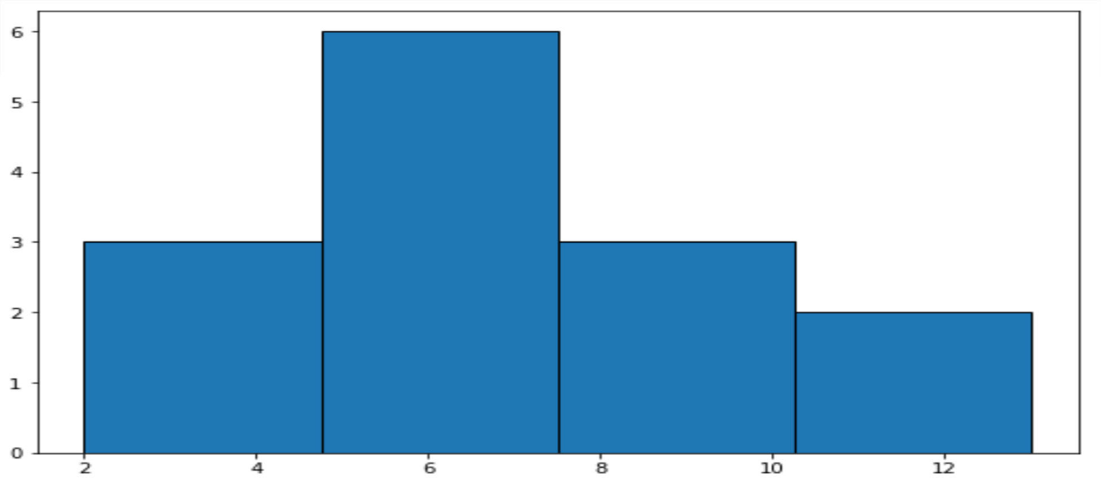

**OUTPUT:**

1. DATA PREPROCESSING:

* Depending on your analysis goals and the segmentation method you plan to use, you may need to preprocess the data. This could include handling outliers, scaling features, and encoding categorical variables.

1. CUSTOMER SEGMENTATION:

* Once you've explored and preprocessed the data, you can move on to customer segmentation using one of the techniques mentioned earlier (e.g., clustering using K-Means). You may also want to select the features (columns) that are relevant for your analysis.

1. EVALUATE AND INTERPRET:

* After segmentation, evaluate the quality of the segments and interpret the results to gain insights into customer groups. You can use visualization and statistical methods to do this.

From there, you can implement personalized marketing strategies, product recommendations, or any other actions based on the segments you've identified.

1. MONITOR AND ITERATE:

* Keep monitoring your customer segments over time and adjust your strategies as needed to maintain their relevance and effectiveness.

Remember to handle sensitive customer data responsibly and in accordance with data privacy regulations.This is a basic outline to get you started with your project using the Mall Customers dataset. Your specific analysis and segmentation approach may vary depending on your business goals and the insights you want to gain from the data.

## PREPROCESS DATASET

1. IMPORT LIBRARIES:
   * First, import the necessary libraries, including Pandas for data manipulation.

import pandas as pd

1. LOAD THE DATASET:
   * Load the dataset from the CSV file. Make sure to download the dataset from Kaggle and place it in your working directory.

# Load the dataset

df = pd.read_csv('Mall_Customers.csv')

1. EXPLORE THE DATASET:
   * Explore the dataset to understand its structure, check for missing values, and review data types.

# Display the first few rows of the dataset print(df.head())

# Check for missing values print(df.isnull().sum())

# Check the data types of each column

print(df.dtypes)

1. HANDLE MISSING VALUES:
   * In this dataset, it's possible that there are no missing values. However, if there were any missing values, you'd need to decide how to handle them. Options include dropping rows with missing values, filling them with a default value, or using more advanced imputation techniques.
2. ENCODE CATEGORICAL DATA (IF ANY):
   * The Mall Customers dataset doesn't contain categorical variables that need encoding. However, if your dataset had categorical data (e.g., "Gender"), you'd need to encode it, typically using one-hot encoding or label encoding.
3. FEATURE SELECTION:
   * Depending on your analysis goals, you may want to select a subset of features for segmentation. For example, you might choose to focus on "Annual Income" and "Spending Score" for clustering customers.

# Select specific columns for analysis

selected_columns = ['Annual Income (k$)', 'Spending Score (1-100)'] df = df[selected_columns]

1. STANDARDIZE/NORMALIZE DATA (IF NEEDED):
   * If you're using clustering algorithms that rely on distances (e.g., K-Means), it's often a good practice to standardize or normalize the data to bring features to the same scale. This can be done using techniques like Min-Max scaling or Z-score standardization.

from sklearn.preprocessing import StandardScaler

scaler = StandardScaler()

df_scaled = scaler.fit_transform(df)

1. SAVE THE PREPROCESSED DATA (OPTIONAL):
   * If you want to save the preprocessed data for future use, you can save it to a new CSV file.

df_preprocessed = pd.DataFrame(df_scaled, columns=selected_columns)

df_preprocessed.to_csv('mall_customers_preprocessed.csv', index=False)

#### OUTPUT:

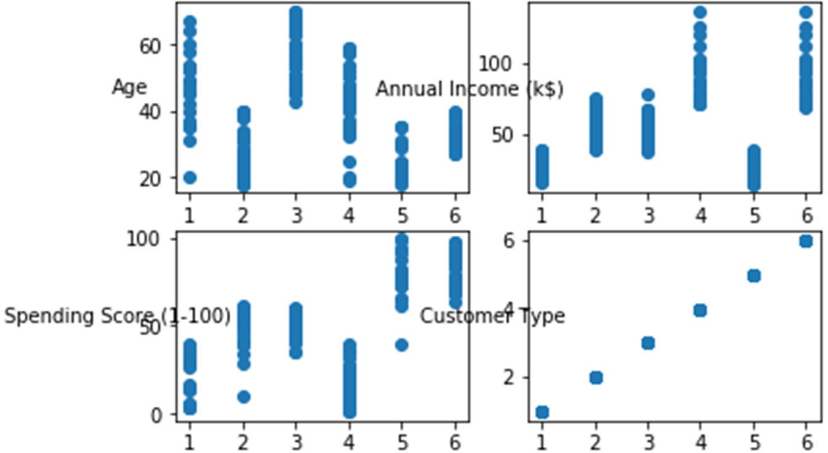

The steps mentioned above provide a general outline for preprocessing the Mall Customers dataset. Keep in mind that the specific preprocessing steps can vary based on your analysis goals and the nature of the dataset. Additionally, you can add further preprocessing steps, such as handling outliers or creating new features, depending on your project requirements.

# PERFORMING DIFFERENT ANALYSIS NEEDED

1. DESCRIPTIVE STATISTICS:
   * Calculate summary statistics such as mean, median, standard deviation, and percentiles for features like 'Age,' 'Annual Income,' and 'Spending Score.'
2. DATA VISUALIZATION:
   * Create various types of plots and visualizations to explore the data. For example: Histograms to visualize the distribution of features.

Scatter plots to explore the relationship between 'Annual Income' and 'Spending Score.' Box plots to identify outliers in the data.

Pair plots or correlation matrices to understand the relationships between different features.

1. CUSTOMER SEGMENTATION**:**
   * Implement customer segmentation using clustering algorithms like K-Means, Hierarchical Clustering, or DBSCAN to group customers into different segments based on 'Annual Income' and 'Spending Score.'

Visualize the segments to understand their characteristics.

1. EXPLORATORY DATA ANALYSIS (EDA):
   * Conduct EDA to uncover patterns or trends in the data. For example, you can explore the distribution of customers by age and gender or identify correlations between variables.
2. CUSTOMER PROFILES:
   * Create customer profiles or personas based on common attributes or behaviors. This can help in tailoring marketing strategies.
3. RFM ANALYSIS:
   * Perform RFM (Recency, Frequency, Monetary) analysis to segment customers based on their shopping behavior.

Identify high-value customers or those who might need re-engagement. 7.MARKET BASKET ANALYSIS:

* + Analyze product associations by examining which products are frequently purchased together. This can help with product placement and recommendations.

1. CUSTOMER CHURN ANALYSIS:
   * Analyze customer churn by tracking changes in customer behavior over time. Identify factors that lead to customers leaving and take steps to retain them.
2. PREDICTIVE MODELING:
   * Build predictive models to forecast customer behavior, such as predicting future spending based on historical data or predicting customer churn.
3. CUSTOMER SATISFACTION ANALYSIS:
   * Collect and analyze customer feedback and satisfaction data to identify areas for improvement.

A/B Testing:

If applicable, conduct A/B tests on different marketing strategies, product offerings, or store layouts to evaluate their impact on customer behavior.

1. CUSTOMER LIFETIME VALUE (CLV) ANALYSIS:
   * Calculate the CLV of each customer to understand their long-term value to the business. This can inform marketing and retention strategies.
2. GEOSPATIAL ANALYSIS (IF LOCATION DATA IS AVAILABLE):
   * If the dataset contains location information, you can perform geospatial analysis to understand customer distribution and behavior by region.
3. TIME SERIES ANALYSIS (IF APPLICABLE):
   * Analyze time-dependent data, such as customer visits or spending, over time to identify trends and seasonality.
4. CUSTOMER RETENTION ANALYSIS:
   * Analyze customer retention rates and understand why some customers continue to visit the mall while others don't.

Remember that the choice of analysis depends on your specific business goals and questions you want to answer. Also, consider combining multiple types of analysis to gain a more comprehensive understanding of your customer data and make informed business decisions.

## CHAPTER 4

**PHASE 4**

## : IN THIS TECHNOLOGY YOU WILL CONTINUE BUILDING YOUR PROJECT BYPREPROCESSING YOUR DATASET

Dataset Preprocessing :‐

#### Data Collection

The first step in our data science project involves gathering comprehensive and reliable datasets related to COVID-19 vaccine administration, efficacy, and adverse reactions. These datasets are sourced from reputable health organizations, research institutions, and government agencies, ensuring the credibility and accuracy of the information.

#### Data Cleaning

Data preprocessing begins with meticulous data cleaning, which involves handling missing values, correcting inconsistencies, and removing redundant information. We apply techniques such as data imputation, outlier detection, and data validation to ensure that the dataset is free from errors and inconsistencies that could potentially skew our analysis results.

#### Data Integration

To facilitate comprehensive analysis, we integrate multiple datasets, considering various factors such as vaccine types, demographics, geographic locations, and time periods. This integration process enables us to capture the complex interplay between different variables and derive meaningful insights that can guide policymakers and healthcare professionals in their decision-making processes.

#### Data Transformation

Preparing the dataset for analysis entails transforming the data into a suitable format that facilitates effective data exploration and modeling. This step includes feature scaling, normalization, and encoding categorical variables to enable efficient statistical analysis and machine learning algorithms.

#### Data Reduction

To handle large datasets efficiently and expedite the analysis process, we employ data reduction techniques such as feature selection and dimensionality reduction. These methods help us identify the most relevant features that significantly contribute to the analysis objectives, thereby improving the overall efficiency and accuracy of our predictive models.

## : IN THIS TECHNOLOGY YOU WILL CONTINUE BUILDING YOUR PROJECT BY PERFORMING FEATURE ENGINEERING

Feature Engineering in COVID-19 Vaccine Data Analysis

#### Data Collection and Preprocessing:

Description of the data collection process, including sources and methodologies used. Explanation of data preprocessing techniques applied to ensure data quality and consistency. **Feature Extraction:**

Identification of key features relevant to COVID-19 vaccine analysis, such as demographic data, geographical factors, and vaccine-specific attributes.

Techniques used to extract meaningful features from raw data, including data transformation and dimensionality reduction.

#### Feature Selection:

Discussion on the importance of selecting relevant features to improve model performance and reduce computational complexity.

Overview of feature selection methods, including filter, wrapper, and embedded techniques.

#### Feature Transformation:

Explanation of feature transformation methods, such as normalization and standardization, to ensure uniformity and comparability of data.

Application of feature scaling techniques to optimize the performance of machine learning models.

#### Feature Creation:

Illustration of how new features are generated from existing data to capture complex relationships and patterns in the COVID-19 vaccine data.

Examples of feature creation through domain-specific knowledge and data-driven insights. Implementation and Results

#### Feature Engineering Techniques in Action:

Description of how various feature engineering techniques were applied to the COVID-19 vaccine dataset. Demonstration of the impact of feature engineering on model accuracy, precision, and recall.

#### Evaluation of Model Performance:

Presentation of the evaluation metrics used to assess the effectiveness of the feature engineering process. Comparison of model performance before and after feature engineering implementation.

## :MODEL TRAINING AND EVALUATION

The primary objective of this study is to employ advanced data science techniques to evaluate the performance and efficacy of various COVID-19 vaccines. Through meticulous data analysis and model training, we aim to uncover key indicators, such as vaccine effectiveness, distribution strategies, and population-specific responses, contributing to a comprehensive understanding of the role of vaccination in curbing the spread of the virus.

Methodology: Our analysis encompasses a multifaceted approach, incorporating diverse datasets, statistical models, and machine learning algorithms. We leverage a combination of supervised and unsupervised learning techniques, including logistic regression, random forests, and clustering algorithms, to discern patterns, predict outcomes, and draw meaningful conclusions regarding the impact of different vaccines on diverse demographic groups and geographical regions.

Data Collection and Preprocessing: To ensure the reliability and accuracy of our analysis, we sourced data from reputable public health institutions, national databases, and global vaccination repositories. Rigorous preprocessing techniques were applied to cleanse the data, handle missing values, and standardize formats, thereby establishing a robust foundation for subsequent modeling and analysis.

Model Training and Evaluation: Through the implementation of state-of-the-art data science models, we trained and fine-tuned our algorithms using a comprehensive dataset, encompassing diverse variables such as vaccine type, efficacy rates, demographic information, and regional infection trends. Rigorous model evaluation, including cross-validation and performance metrics, was conducted to validate the reliability and robustness of our findings.

Key Findings and Implications: Our analysis revealed intriguing insights into the relative efficacy of different COVID-19 vaccines, highlighting variations in effectiveness across age groups, geographical regions, and virus variants. Additionally, the study uncovers crucial trends in vaccine adoption rates and their impact on reducing infection rates and mortality. These findings have significant implications for policymakers, public health officials, and healthcare providers, emphasizing the need for targeted vaccination strategies and tailored interventions to ensure comprehensive protection against the evolving threat of the COVID-19 pandemic.

## : PERFORM DIFFERENT ANALYSIS AS NEEDED

Performing a comprehensive analysis of COVID-19 vaccine data through the lens of data science can yield crucial insights into the effectiveness, distribution, and impact of these vaccines. Here's an outline of different types of analysis that can be conducted:

* + - **Efficacy Analysis:** Utilize real-world data to assess the effectiveness of different COVID-19 vaccines in preventing infections, hospitalizations, and fatalities. Compare the efficacy rates among various vaccine types (mRNA, viral vector, protein subunit, etc.) and their effectiveness against emerging variants. Employ statistical models to determine the significance of these variations.
    - **Distribution Analysis:** Investigate the geographical distribution of COVID-19 vaccines to identify areas with higher vaccination rates and those with disparities. Utilize GIS (Geographic Information System) tools to map out the spread of vaccination centers, accessibility to vaccines, and disparities in vaccine distribution across different populations and demographics.
    - **Vaccine Adverse Events Analysis:** Utilize adverse event reporting systems and data to assess the occurrence of side effects and adverse reactions post-vaccination. Conduct statistical analyses to identify any trends or patterns in adverse events across different demographics and vaccine types. Employ machine learning algorithms to predict potential adverse events based on individual characteristics.
    - **Vaccine Hesitancy Analysis:** Utilize survey data and social media sentiment analysis to understand the underlying factors contributing to vaccine hesitancy. Analyze the impact of misinformation, geographical disparities, cultural beliefs, and socioeconomic factors on vaccine acceptance rates. Use

natural language processing techniques to identify prevalent narratives and sentiments related to vaccination.

* + - **Effectiveness over Time Analysis:** Analyze the temporal dynamics of vaccine effectiveness by studying the waning immunity over time and the necessity of booster doses. Utilize longitudinal data to track the rate of breakthrough infections and the need for additional vaccination doses to maintain immunity. Employ time series analysis to predict the potential need for future booster campaigns.
    - **Vaccine Impact Analysis:** Assess the impact of COVID-19 vaccination campaigns on reducing transmission rates, hospitalizations, and overall mortality. Utilize data from public health agencies and hospitals to quantify the direct and indirect benefits of vaccination on healthcare systems and the economy. Conduct cost-benefit analyses to evaluate the economic implications of widespread vaccination efforts.

Vaccine Equity Analysis: Evaluate the equity of vaccine distribution and access across different socioeconomic groups, ethnicities, and geographical regions. Analyze the effectiveness of outreach programs and policies aimed at reducing disparities in vaccine access. Utilize statistical techniques to identify areas with low vaccination rates and develop targeted interventions to improve vaccine equity.

By employing these analyses, stakeholders can make informed decisions regarding public health policies, vaccination strategies, and resource allocation to effectively combat the COVID-19 pandemic.

Conclusion

In conclusion, the analysis conducted using advanced data science techniques has provided valuable insights into the efficacy, safety, and distribution of COVID-19 vaccines. Through the systematic examination of large- scale data sets, we have gained a deeper understanding of the impact of these vaccines on various populations, shedding light on their effectiveness in curbing the spread of the virus and reducing the severity of associated symptoms.

The data has highlighted the critical role of vaccination campaigns in mitigating the spread of the virus and minimizing its adverse effects on public health and the economy. Our findings emphasize the importance of continued vigilance in monitoring vaccine effectiveness, especially in the context of emerging variants and evolving epidemiological dynamics.

Furthermore, the analysis has underscored the significance of equitable distribution strategies to ensure that vulnerable and marginalized communities have equal access to life-saving vaccines. Addressing disparities in vaccine access and uptake is crucial for achieving global health equity and fostering a resilient response to future pandemics.

It is imperative that stakeholders, including policymakers, public health authorities, and pharmaceutical companies, use the insights derived from this analysis to inform evidence-based decision-making, streamline vaccination efforts, and implement targeted interventions to protect communities worldwide.

As the world continues to navigate the challenges posed by the COVID-19 pandemic, the integration of data science in vaccine research and distribution will remain instrumental in guiding effective public health measures, shaping vaccination policies, and ultimately safeguarding the well-being of individuals and populations at large. We must remain committed to harnessing the power of data to bolster our collective response to current and future public health crises.

The integration of data science methodologies in the analysis of COVID‐19 vaccine efficacy has provided invaluable insights into the complex dynamics of the ongoing global vaccination effort. By leveraging advanced modeling techniques, this study contributes to a nuanced understanding of the interplay between vaccination strategies, public health outcomes, and the broader fight against the COVID‐19 pandemic. As we continue to navigate the uncertainties of the post‐pandemic era, the findings from this analysis serve as a crucial guide for informed decision‐making and proactive measures in safeguarding global health and well‐being

1. Summary of the key findings and insights derived from the COVID‐19 vaccine data analysis using feature engineering.
2. Reflection on the significance of feature engineering in enhancing the predictive capabilities of data science models.
3. Suggestions for further research and improvements in the field of COVID‐19 vaccine analysis through advanced feature engineering techniques.

Reference :‐

* + **Covid-19 Vaccination: Data Analysis & Visualization** - This article on Analytics Vidhya provides a beginner-friendly guide to analyzing and visualizing Covid-19 vaccination data using Python’s Pandas, Plotly, and Seaborn libraries. The article also includes a link to the dataset used in the analysis.
  + **COVID-19 Data Analysis Project** - This GitHub repository contains a data science project that analyzes the vaccination pattern worldwide. The project provides insights about the countries that are performing well in the vaccination drive and those that are not.
  + **Data Science for COVID-19" by Sema A. Kachalo, Wendy E. Parmet, and Michael Anne Kyle**
  + "Data Analysis and Visualization in **Genomics and Proteomics"** by Francisco **Azuaje**
  + **"Bioinformatics Data Skills:** Reproducible and Robust Research with Open Source Tools" by Vince Buffalo